Online Coaxial / Twisted Pair Surge Protection Device
ITEM NO: SP001, SP001VPD, SP004, SP016C,


Application for protects equipment from high voltage surges such as lightning strikes. UL grounding requirements for coaxial cable offer protection from hazardous voltages that may occur on the shielding. Because of the physical length of ground wires, UL grounding systems may appear as an open circuit to lightning caused, high frequency surges and provide no protection from these surges getting into a home and destroying CATV converters, TV sets, VCR, Camera etc.

FCC

Features:

- Performs a different function than grounding requirements.
- Protects equipment from high voltage surges from nearby lightning strikes.
- Two stage protection: 130V, AC/DC 12V
- Wide range of applications: CCTV system, Antenna of Television, satellite receivers, FM receivers, video camera, monitors, multiplexers & Quad processor, VCR, etc.

SP001 Coaxial Surge Protection Device BNC Connector
BNC male to BNC female. Hi Frequency for both CCTV and CATV use.

SP001VPD Video, Power, Data Surge Protection
5 pin terminal + BNC female to 4 pin terminal + BNC female.
Two stage protection, AC/DC 130V, AC/DC 12V
Max power input AC 40V(MAX), DC 56V(MAX).

SP004 UTP Data Surge protection Device Terminal Connector
Terminal connector to terminal connector.
Perfect for video or data signal protection

SP016C Video Surge Protection For DVR in 1U Rack Mounting Panel
16 BNC female to 16 BNC female,
Provide protection for DVR, multiplexers or any equipment with multiple video inputs.

Installation View:
SP001
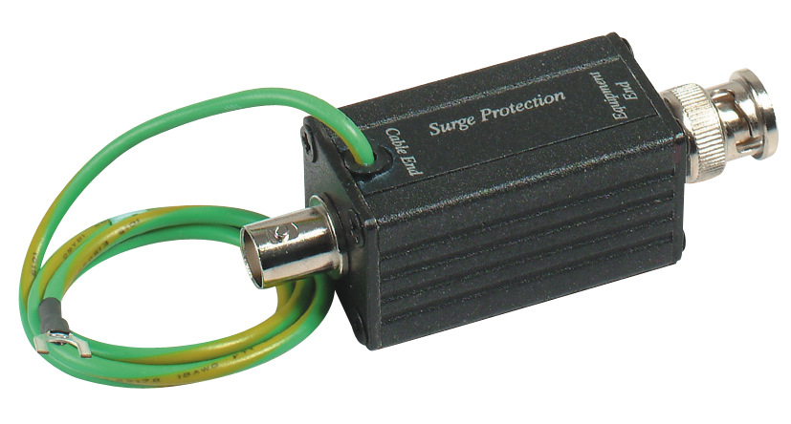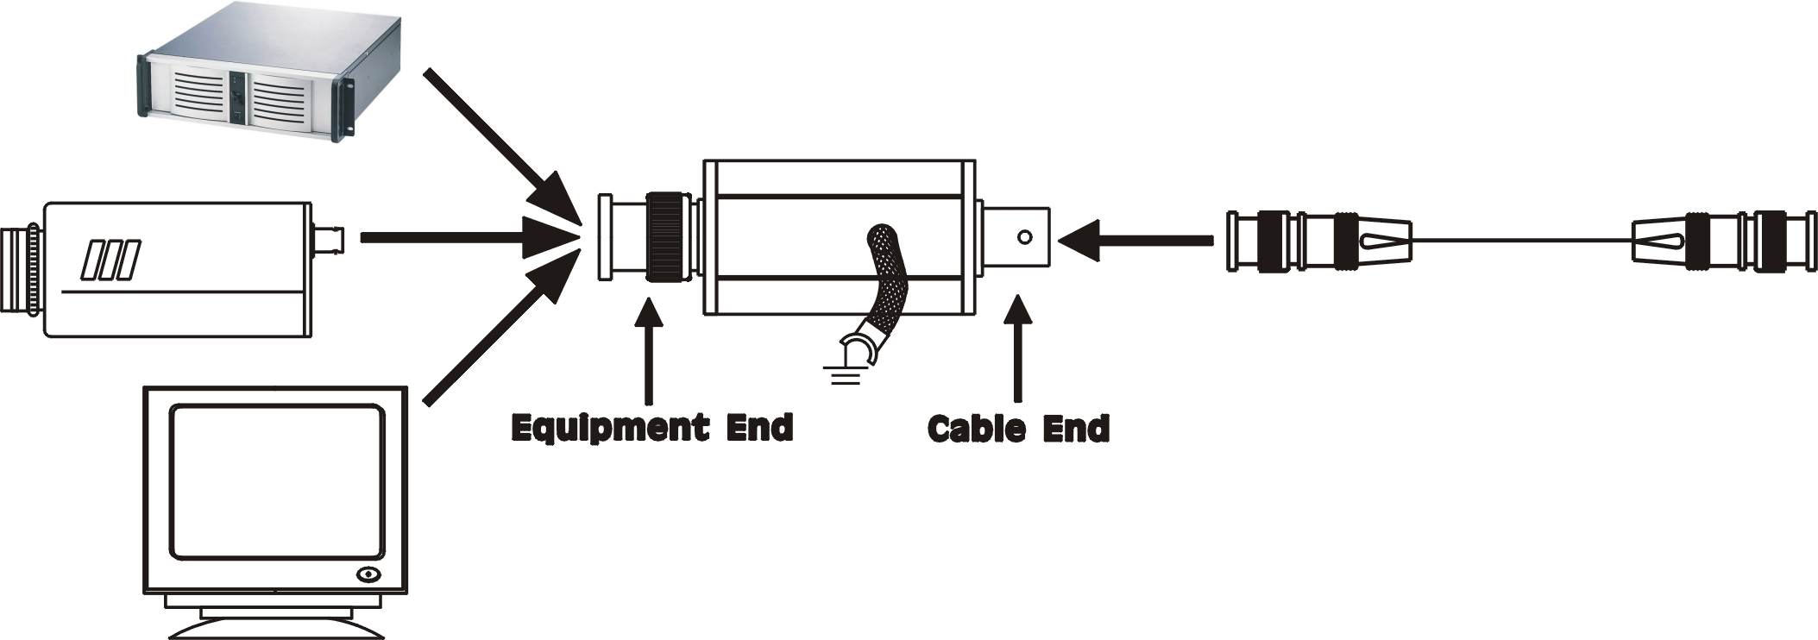

SP001VPD
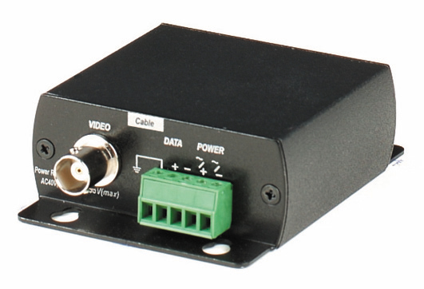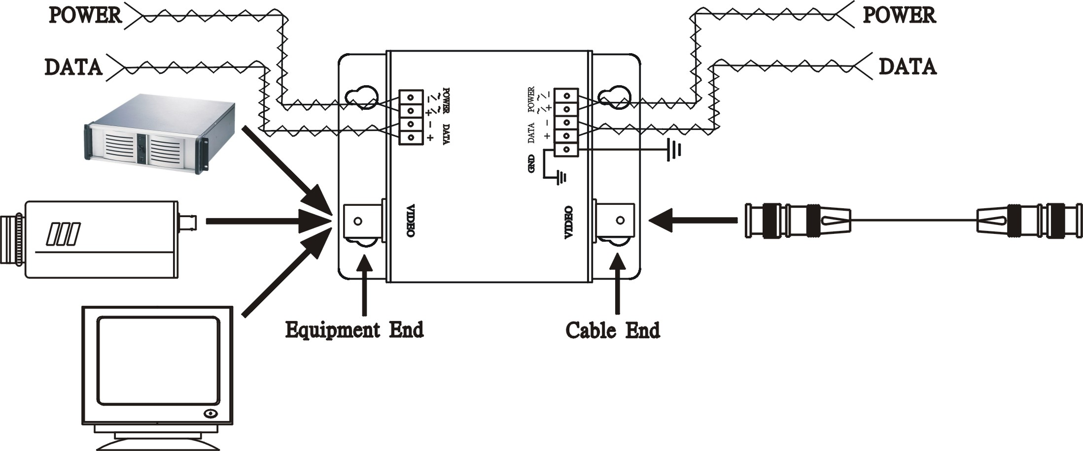

SP004
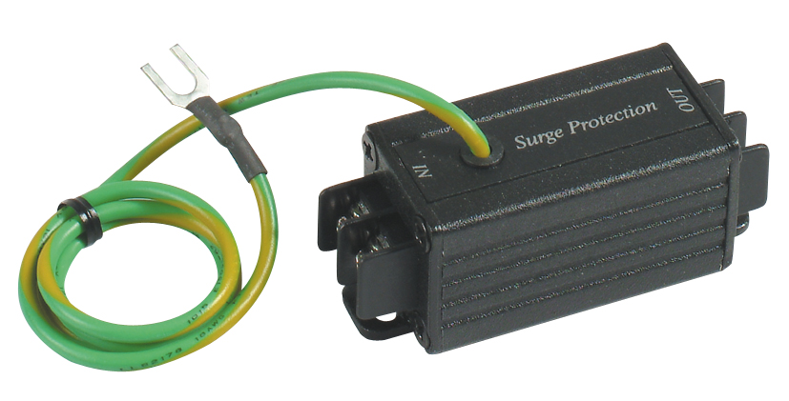

SP016C
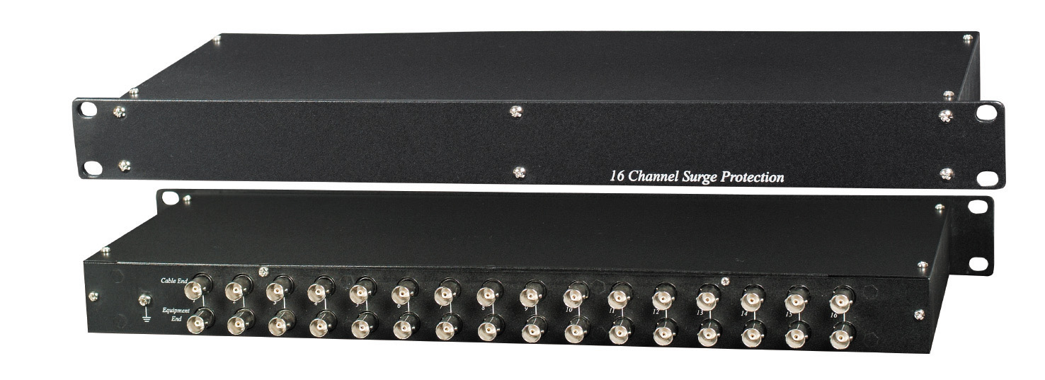

SP016C
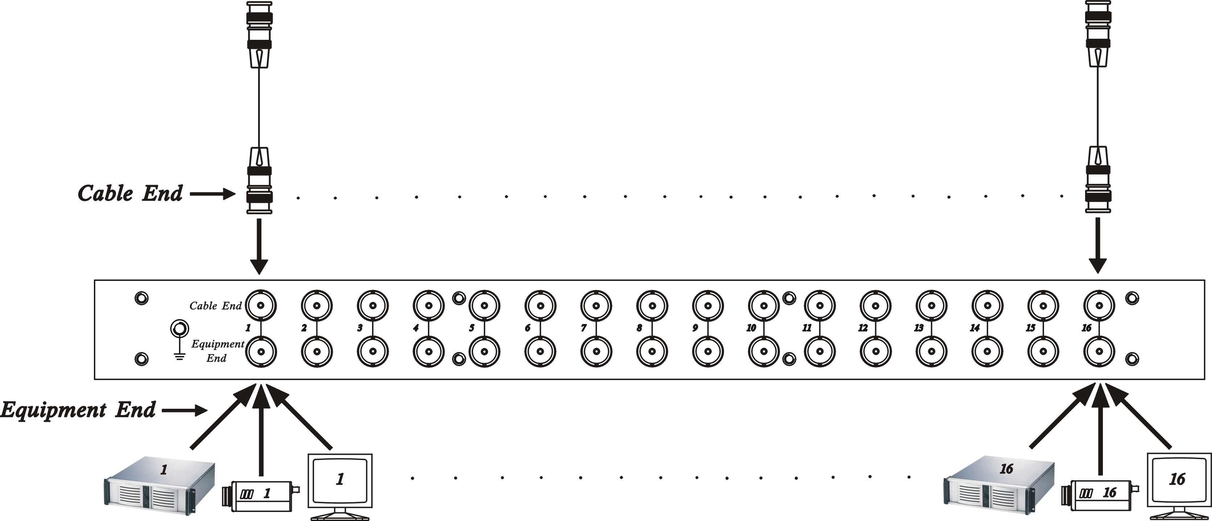

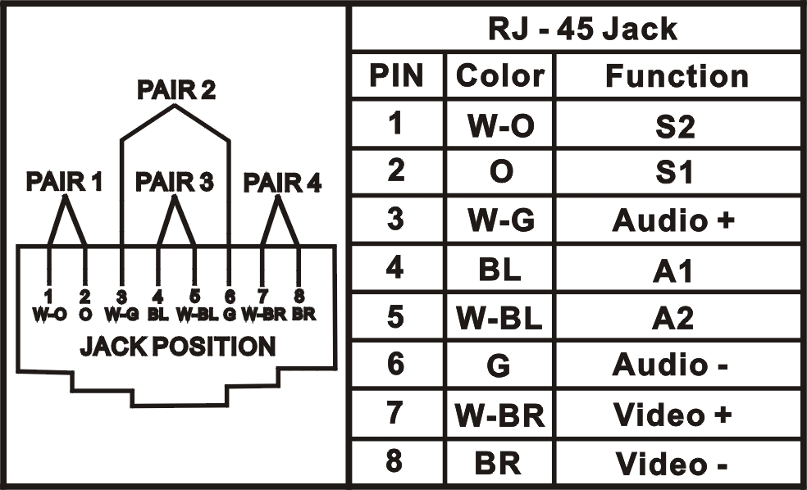

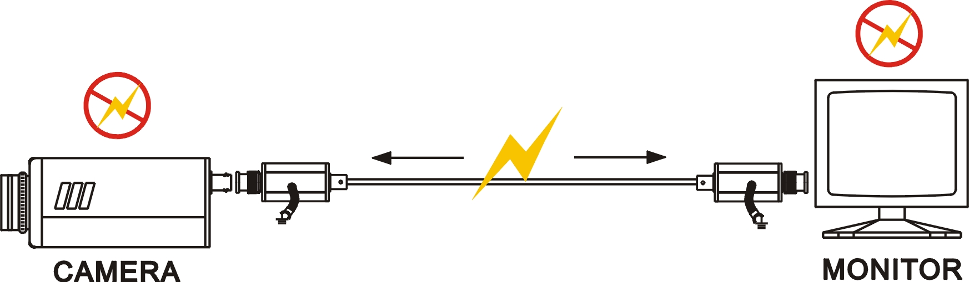

Application
Note:
For ensuring the unit can protect equipments, the cable must be connected to ground.

- CATV System
- Antenna of Television
- Video Cassette Recorders
- FM receivers
- Video Cameras and monitors
- Multiplexers and Quad Processor

Specification:

ITEM NO. | SP001 | SP001VPD | SP004 | SP016C
Surge Protection Attack Time | 1 ns
Maximum Surge Current | 4 KV
Surge Life | 300 surges of 100Amps
Normal Resistance Across Coax | 10,000 MΩ
Surge Resistance | Approx. 0Ω
BAND PASS | 0~1 GHZ
Power Passing Capability | 130V AC / DC, 65 Vrms at10 Amps
Insertion Loss | Less than 0.2 dB
Return Loss (75 ohms) | 16dB
Power IN Put – for SP001VPD | AC 40V(MAX), DC56V(MAX)
Connectors | BNC | Terminal | Terminal | BNC
Dimensions W x H x D mm | 78x25x25 | 87x67x27 | 65x25x25 | 482x170x 44mm standard 1U Rack Panel
WEIGHT g | 80 | 136 | 65 | 1200

