Online Coaxial Surge Protection Device
ITEM NO: SP001, SP001P


Application for protects equipment from high voltage surges such as lightning strikes. UL grounding requirements for coaxial cable offer protection from hazardous voltages that may occur on the shielding. Because of the physical length of ground wires, UL grounding systems may appear as an open circuit to lightning caused, high frequency surges and provide no protection from these surges getting into a home and destroying CATV converters, TV sets, VCR, Camera etc.

FCC

Features:

- Performs a different function than grounding requirements.
- Protects equipment from high voltage surges from nearby lightning strikes.
- Two stage protection: 130V, AC/DC 12V
- Wide range of applications: CCTV system, Antenna of Television, satellite receivers, FM receivers, video camera, monitors, multiplexers & Quad processor, VCR, etc.

SP001 Coaxial Surge Protection Device BNC Connector
BNC male to BNC female. Hi Frequency for both CCTV and CATV use.

SP001P Power Surge protection Device
2 pin terminal for power input to 2 pin terminal for power output.
Two stage protection, AC/DC 130V
Max power input AC 40V(MAX), DC 56V(MAX)

Installation View:
SP001
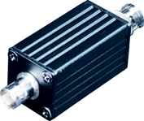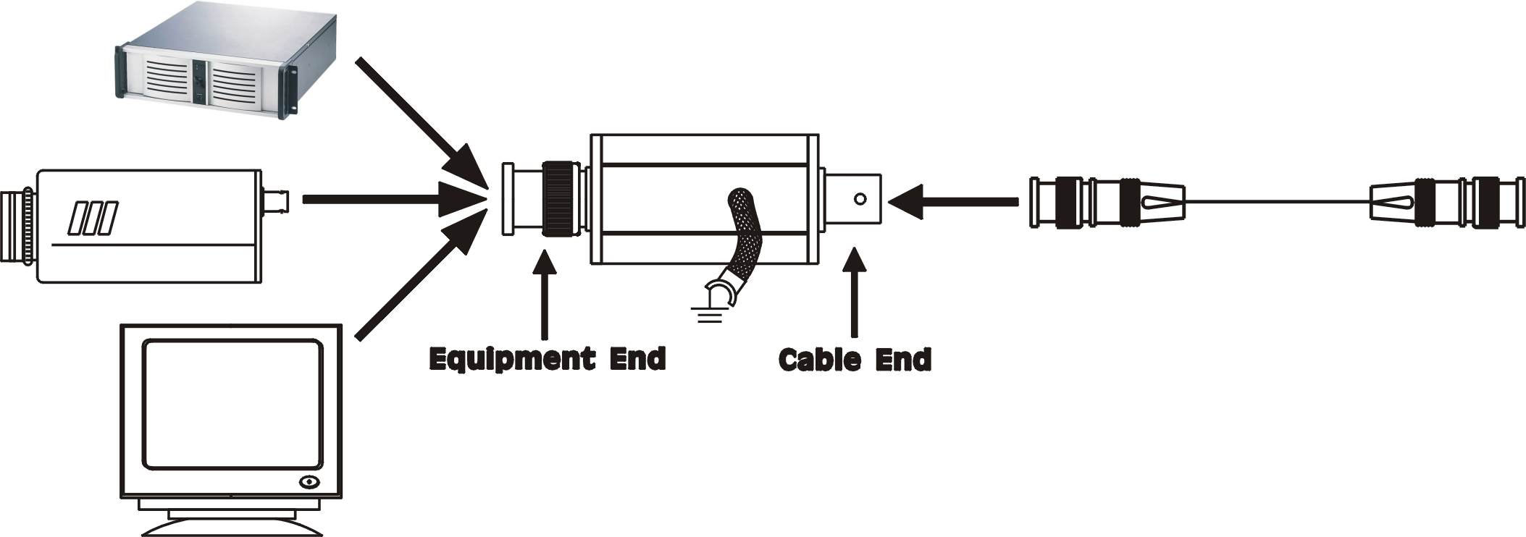

SP001P
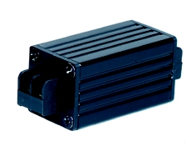

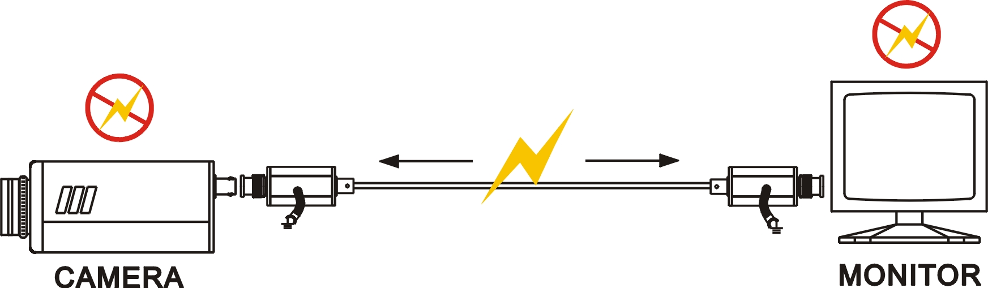

Application
Note:
For ensuring the unit can protect equipments, the cable must be connected to ground.

- CATV System
- Antenna of Television
- Video Cassette Recorders
- FM receivers
- Video Cameras and monitors
- Multiplexers and Quad Processor

Specification:

ITEM NO. | SP001
Surge Protection Attack Time | 1 ns
Maximum Surge Current | 4 KV
Surge Life | 300 surges of 100Amps
Normal Resistance Across Coax | 10,000 MΩ
Surge Resistance | Approx. 0Ω
BAND PASS | 0~1 GHZ
Power Passing Capability | 130V AC / DC, 65 Vrms at10 Amps
Insertion Loss | Less than 0.2 dB
Return Loss (75 ohms) | 16dB
Connectors | BNC
Dimensions W x H x D mm | 78x25x25
WEIGHT g | 80

ITEM NO. | SP001P
Surge Protection Attack Time | 1 ns
Maximum Surge Voltage | 4 KV
Surge Life | 300 surges of 100Amps
Normal Resistance Across Coax | 10,000 MΩ
Surge Resistance | Approx. 0Ω
BAND PASS | 0~1 GHZ
Power Passing Capability | 130V DC / AC, 65 Vrms at10 Amps
Insertion Loss | Less than 0.2 dB
Return Loss (75 ohms) | 16dB
Power IN Put | AC 40V(MAX), DC56V(MAX)
Connectors | Terminal
Dimensions W x H x D mm | 65x25x25
WEIGHT g | 65

