AC Power Surge Protection Device
ITEM NO.: SP001P-AC
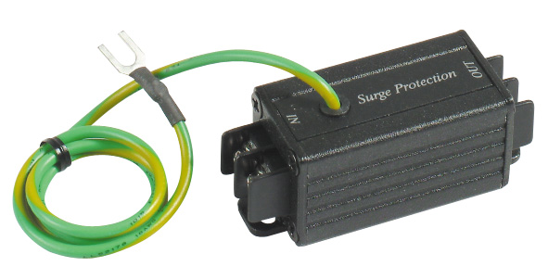
Features:

- Performs a different function than grounding requirements.
- Protects equipment from high voltage surges from nearby lightning strikes.
- Application for protect AC100-120V, AC220-240V power.

SP001P-AC AC Power Surge protection Device Terminal Connector
Terminal connector to terminal connector.
Under 1ns – 400V

Installation View:


Specification:

ITEM NO. | SP001P-AC
Surge Protection Attack Time | 1 ns
Maximum Surge Voltage | 4 KV
Surge Life | 300 surges of 100Amps
Normal Resistance Across Coax | 10,000 MΩ
Surge Resistance | Approx. 0Ω
BAND PASS | 0~1 GHZ
Power Passing Capability | AC 400Vp-p, 65 Vrms at 10 Amps
Connectors | Terminal
Dimensions W x H x D mm | 65x25x25
WEIGHT g | 65

