Twisted Pair Surge Protection Device

ITEM NO.: SP016T 16 Terminal connector to 16 terminal connector.

Application for protects equipment from high voltage surges such as lightning strikes. UL grounding requirements for coaxial cable offer protection from hazardous voltages that may occur on the shielding. Because of the physical length of ground wires, UL grounding systems may appear as an open circuit to lightning caused, high frequency surges and provide no protection from these surges getting into a home and destroying CATV converters, TV sets, VCR, Camera etc.

FCC C-TICK

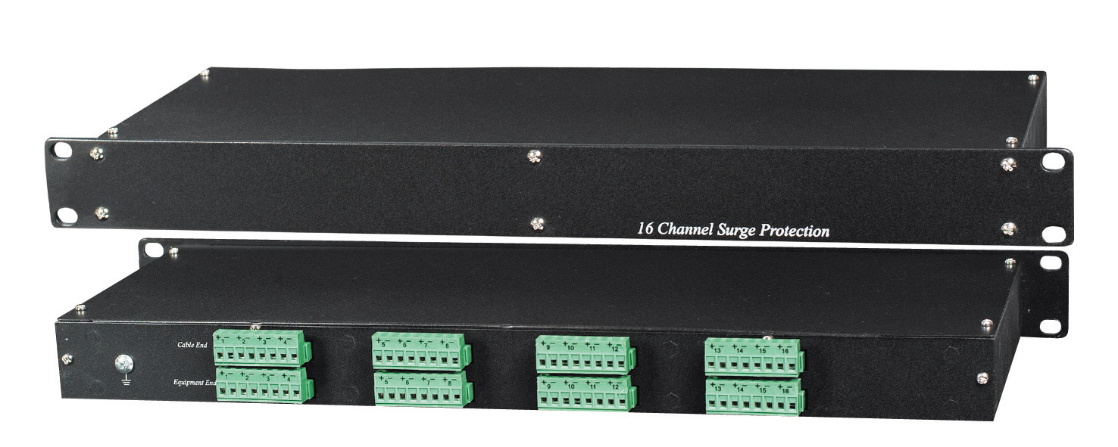

Features:
- Performs a different function than grounding requirements.
- Protects equipment from high voltage surges from nearby lightning strikes.
- Two stage protection: under100ns – 90V, over 100ns-12V.
- Wide range of applications: CCTV system, Antenna of Television, satellite receivers, FM receivers, video
- Provide protection for DVR, multiplexers or any equipment with multiple video inputs.

Installation View:

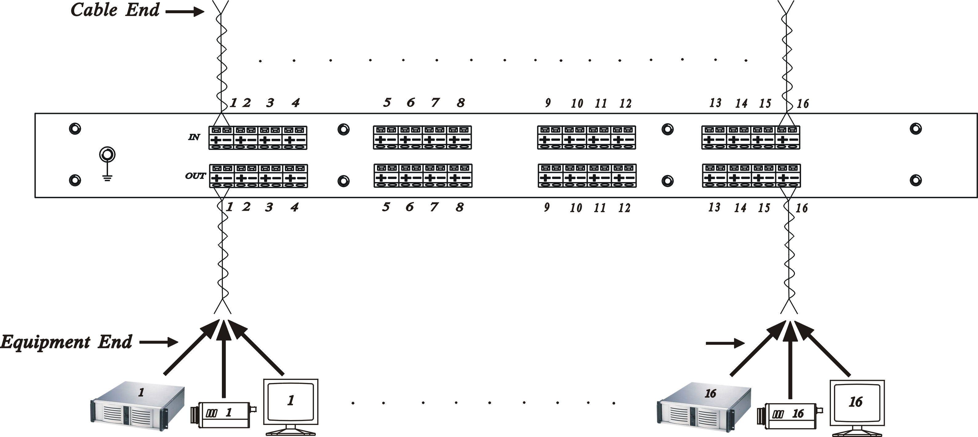

Specification

Item | SP016T
Surge Protection Attack Time | 1 ns
Maximum Surge Current | 4 KV
Surge Life | 300 surges of 100Amps
Normal Resistance Across Coax | 10,000 MΩ
Surge Resistance | Approx. 0Ω
BAND PASS | 0~1 GHZ
Power Passing Capability | DC 90V, AC 90Vp-p, 65 Vrms at10 Amps
Insertion Loss | Less than 0.2 dB
Return Loss (75 ohms) | 16dB
Connectors | Terminal
Dimensions mm | 482x170x 44mm standard 1U Rack Panel
WEIGHT g | 1200

